Overview

This document describes the creation of a Visual Basic .NET GUI used to demonstrate I2C communication with the Microchip 28 Pin Demo board.

History

4-13-07 - Original
6-22-07 – Updated to use new Device class

Requirements

- Visual Basic 2005 Express (free download from Microsoft) or Visual Studio 2005
- 28 Pin Demo Board
- PICkit Serial Analyzer, firmware version 0201 or later
- PICkitS.dll software, version 1.5.0.0 or later

The example GUI in this document will be created using Visual Basic 2005 Express. If you are using Visual Studio, some pictures will vary slightly.

Project creation and dll linking

- Open Visual Basic Express and create a new Windows project (File -> New Project -> Windows Application.
- Name the project I2CExample.
- In the Solution Explorer (upper right corner), select the project I2CExample, then press the “Show All Files” button to reveal all files.

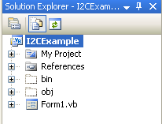

- Right click on References and select ‘Add Reference’ to add the PICkit Serial DLL.
- Select the Browse Tab and navigate to PICkitS.dll and select it. (If you have PICkit Serial Analyzer installed, you can find the dll at C:\Program Files\Microchip\PICkit Serial Analyzer). This allows the GUI to have access to functions embedded in the dll.
- The Solution Explorer should now look like this:
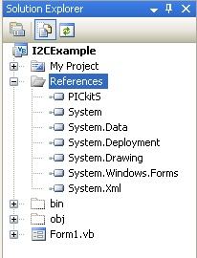

EE read

- Enlarge the Form a bit and add the following items:

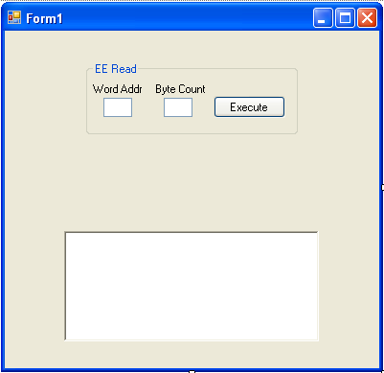

- Two textboxes, two labels, a button and a groupbox to hold them all
- A richtextbox to display data

- Change the text for the labels, button and groupbox to match the picture above by selecting each and changing the Text in the Properties (lower right corner of IDE)

- Rename the objects per below by selecting each object, then changing the Name in the Properties (lower right corner of IDE):

  - TextBox_Read_EE_Word_Addr
  - TextBox_Read_EE_Byte_Count
  - Button_Read_EE_Execute
  - RichTextBox_Display

The groupbox and labels do not need to be renamed.

Now let’s add some initialization code to the form. This will set up the dll properly, configure the PICkit Serial Analyzer for I2C communication, and inform the user of the initialization status.

- Click on the Form in the [Design] tab, and double click the Title bar at the top of the form. This will create a function Form1_Load. Inside this function, type the following:

Private Sub Form1_Load(ByVal sender As System.Object, ByVal e As System.EventArgs) Handles MyBase.Load
If (PICkitS.Device.Initialize_PICkitSerial()) Then
If (PICkitS.I2CM.Configure_PICkitSerial_For_I2CMaster()) Then
RichTextBox_Display.Text += "PICkit Serial correctly configured for I2C" & vbCrLf
Else
RichTextBox_Display.Text += "Error configuring PICkit Serial for I2C" & vbCrLf
End If
Else
RichTextBox_Display.Text += "Error initializing PICkit Serial" & vbCrLf
End If
End Sub

Note – when you finish typing ‘PICkitS’ and type the ‘.’ A context window should open up and you can select Device by using the up/down arrows to highlight ‘Device’, then pressing the tab key to select it. Do the same with I2C. and Configure_PICkitSerial_For_I2CMaster and add the parens yourself. Pretty cool! The vbCrLf adds a carriage return Line Feed.

- Now we add some cleanup code. Click on the Form in the [Design] tab and in the properties window (lower right corner) select the Events button (lightening bolt) and double click the FormClosed event. Inside that function, type:

PICkitS.Device.Cleanup()

This kills all communication threads and releases dll resources.

- From the menu, press Build -> Build I2CExample to make sure you have no errors at this point. If it does not build correctly, find and fix your errors – they are probably just typos.

- Let’s test your application – all it will do is find and initialize the PICkit Serial Analyzer. Attach the PICkit Serial Analyzer via a USB cable and Press the Start Debugging button

Your application should startup and display the status:

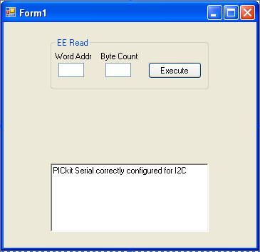

If your application does not find and configure the PICkit Serial Analyzer correctly, check your connections and verify that it is listed under Human Interface Devices in the Device Manager. If you are connecting the PICkit Serial Analyzer through a USB hub, try removing the hub and connecting directly to the PC.

- Close your application.

Now let’s add some code to read the 28 Pin Demo Board EE.

- Double click the Execute button and add this code:

Dim Demo_Slave_ee_Addr As Byte = &HA8
' determined by Demo board firmware, &H says this is a hex number
Dim Word_Addr As Byte = Convert.ToByte(TextBox_Read_EE_Word_Addr.Text, 16)
' assume value in textbox is hex
Dim Byte_Count As Byte = Convert.ToByte(TextBox_Read_EE_Byte_Count.Text, 16)
' assume value in textbox is hex
Dim DataArray(256) As Byte
' will store returned data here
Dim Return_Str As String = ""
' returns string representation of command - we won't use this
Dim Display_Str As String = ""
' will display results with this
Dim index As Integer
' used as counter
'
' clear array
For index = 0 To Byte_Count - 1
DataArray(index) = 0
Next
'
If (PICkitS.I2CM.Read(Demo_Slave_ee_Addr, Word_Addr, Byte_Count, DataArray, Return_Str)) Then
' successful, display results
For index = 0 To Byte_Count - 1
Display_Str += Convert.ToString(DataArray(index), 16) & " "
Next
RichTextBox_Display.Text += Display_Str & vbCrLf
Else
RichTextBox_Display.Text += "Error reading Demo Board EE" & vbCrLf
PICkitS.Device.Reset_Control_Block() ' clear any errors in PKSA
End If
- Build your project, fix any errors and press the Start Debugging button. When the GUI appears, insert the values 00 and 05 into the Word Addr and Byte Count textboxes. Press the Execute button and check your results. It should look like this

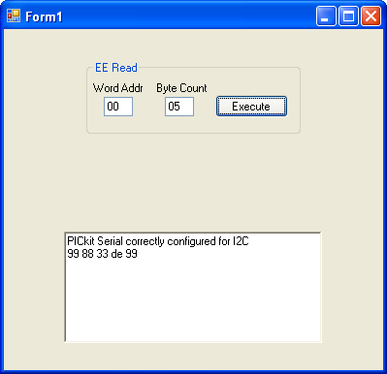

You make get different values depending on what is in your Demo board EE.

- Disconnect the Demo board from the PICkit Serial Analyzer and press the Execute button again to verify that it fails.

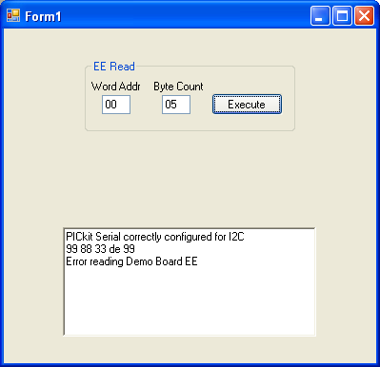

- Close your application.

EE write

- Add the write objects below to the form

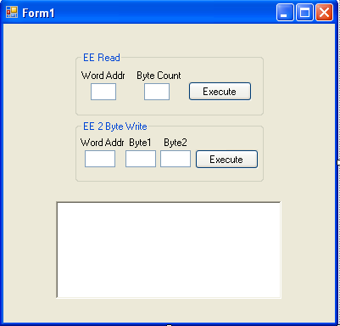

Name the textboxes and button:

  - TextBox_Write_EE_Word_Addr
  - TextBox_Write_EE_Byte1
  - TextBox_Write_EE_Byte2
  - Button_Write_EE_Execute

We are adding objects to facilitate writing two bytes to the EE. You can easily extend the logic to write up to 255 bytes at a time.

- Double click the Write Execute button and add this code:

' routine to write 2 byte to Demo board EE
Dim Demo_Slave_ee_Addr As Byte = &HA8
' determined by Demo firmware, &H says this is a hex number
Dim Word_Addr As Byte = Convert.ToByte(TextBox_Write_EE_Word_Addr.Text, 16)
' assume value in textbox is hex
Dim Byte1 As Byte = Convert.ToByte(TextBox_Write_EE_Byte1.Text, 16)
' assume value in textbox is hex
Dim Byte2 As Byte = Convert.ToByte(TextBox_Write_EE_Byte2.Text, 16)
' assume value in textbox is hex
Dim DataArray(1) As Byte
' create array of length 2 bytes
' will store write data here - sized to fit our two bytes
Dim Return_Str As String = ""
' returns string representation of command - we won't use this
DataArray(0) = Byte1
DataArray(1) = Byte2
' fill array
If (PICkitS.I2CM.Write(Demo_Slave_ee_Addr, Word_Addr, DataArray.Length, DataArray, Return_Str)) Then
' success
RichTextBox_Display.Text += "Writing to EE successful" & vbCrLf
Else
RichTextBox_Display.Text += "Error writing to EE" & vbCrLf
PICkitS.Device.Reset_Control_Block() ' clear any errors in PKSA
End If

- Let’s test the write command. Build your project and press the Start Debugging Button.
- Read 5 bytes from word address 0 using the read command.
- Then write two bytes to the same address
- Repeat the read to verify the write worked.

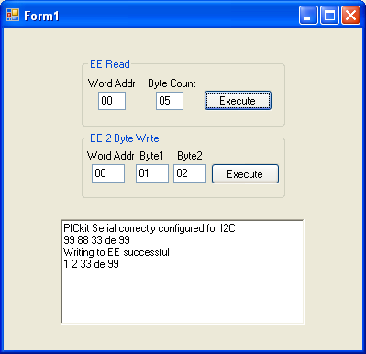

Both reading and writing can be extended to handle up to 255 bytes per transaction. Just make sure your arrays are sized accordingly and to execute the

PICkitS.Device.Reset_Control_Block()

command if either fails. This command clears any error flags set in the PICkit Serial Analyzer. For detailed information about errors that are generating, it is recommended that you duplicate your commands in the PICkit Serial Analyzer GUI and examine the status pane error bits.

EE Receive

- Add the Receive objects below to the form.

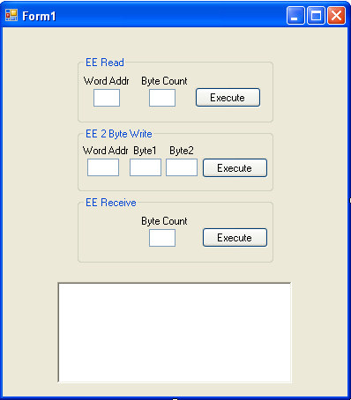

Name the textbox and button as follows

  - TextBox_Receive_EE_Byte_Count
  - Button_Receive_EE_Execute

- Double click the Receive Execute button and add this code:

Dim Demo_Slave_ee_Addr As Byte = &HA9
' determined by Demo board firmware, &H says this is a hex number
' IMPORTANT - addr is not same as for Read command
' that command automatically increments the write addr to
' obtain the read addr
Dim Byte_Count As Byte = Convert.ToByte(TextBox_Receive_EE_Byte_Count.Text, 16)
' assume value in textbox is hex
Dim DataArray(256) As Byte
' will store returned data here
Dim Return_Str As String = ""
' returns string representation of command - we won't use this
Dim Display_Str As String = ""
' will display results with this
Dim index As Integer
' used as counter
'
' clear array
For index = 0 To Byte_Count - 1
DataArray(index) = 0
Next
'
If (PICkitS.I2CM.Receive(Demo_Slave_ee_Addr, Byte_Count, DataArray, Return_Str)) Then
' successful, display results
For index = 0 To Byte_Count - 1
Display_Str += Convert.ToString(DataArray(index), 16) & " "
Next
RichTextBox_Display.Text += Display_Str & vbCrLf
Else
RichTextBox_Display.Text += "Error receiving from Demo Board EE" & vbCrLf
PICkitS.Device.Reset_Control_Block() ' clear any errors in PKSA
End If

- Now let’s test it. Start your application and use the Read command to read 5 bytes from address 00.
- Now read 1 byte from address 00 using the same command.
- Now read 1 byte at a time using the Receive command and verify those bytes match the ones read in step 3.

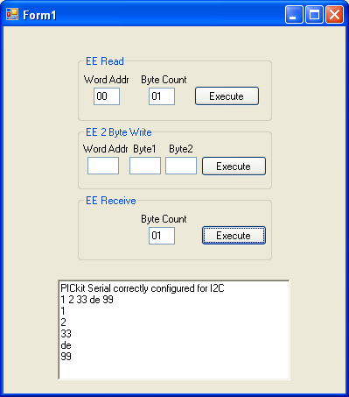

The Receive command does not supply a word address or command. It relies on the hardware and firmware to know how to respond to the I2C command. In the case of this EE, the device responds with the data stored in the EE address just after the address of the last query.

Real Time Clock (RTC)

Now let’s look at the RTC.

- Add three new objects to the GUI and name them per below (you may have to increase the size of the GUI some):

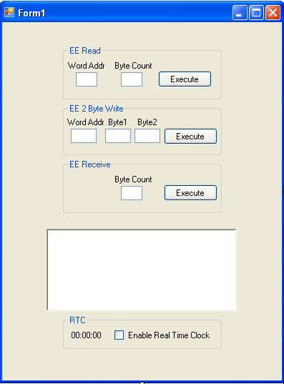

  - Label_RTC
  - CheckBox_RTC

Rather than using a button to constantly check and update the time, we will use a timer.

- Add a timer to the form by dragging a timer object from the toolbox to the form.
- Click on the timer (visible below the form) and rename it in the properties window to Timer_RTC.
- Change the Interval to 500 ms.
- Now double click on the timer to create a subroutine called Timer_RTC_Tick
- Add the following code to the timer function

' routine to read and display RTC
' RTC data will be stored in DataArray as follows:
' DataArray(0) = seconds
' DataArray(1) = minutes
' DataArray(2) = hours
' DataArray(3) = weekday
' DataArray(4) = day of the month
' DataArray(5) = month
' DataArray(6) = year
' we will only be displaying hours, minutes, seconds
'
Dim Demo_Slave_RTC_Addr As Byte = &HA2
' determined by SMB firmware, &H says this is a hex number
Dim Word_Addr As Byte = 2
' RTC data starts in location 2
Dim DataArray(6) As Byte
' create array of length 7 bytes to hold rtc data
Dim Return_Str As String = ""
' returns string representation of command - we won't use this
Array.Clear(DataArray, 0, DataArray.Length)
' quicker way of clearing data
If (PICkitS.I2CM.Read(Demo_Slave_RTC_Addr, Word_Addr, DataArray.Length, DataArray, Return_Str)) Then
' successful, display results
Label_RTC.Text = Convert.ToString(DataArray(2), 16) & ":" & Convert.ToString(DataArray(1), 16) & ":" & Convert.ToString(DataArray(0), 16)
' this is easy to display because the data is already in binary coded decimal
' up to reader to force 2 digit values (ie display 01:05:37 instead of 1:5:37)
Else
RichTextBox_Display.Text += "Error reading RTC" & vbCrLf
PICkitS.Device.Reset_Control_Block() ' clear any errors in PKSA
' turn off timer so don't keep getting error
Timer_RTC.Enabled = False
CheckBox_RTC.Checked = False
End If

- Now double click the checkbox to create a function to toggle on and off the timer.
- Add the following code to the checkbox subroutine:

If (CheckBox_RTC.Checked) Then
Timer_RTC.Enabled = True
Else
Timer_RTC.Enabled = False
End If

- Build and run your application, then click on the checkbox to enable the timer. You should get a display that looks something like this:

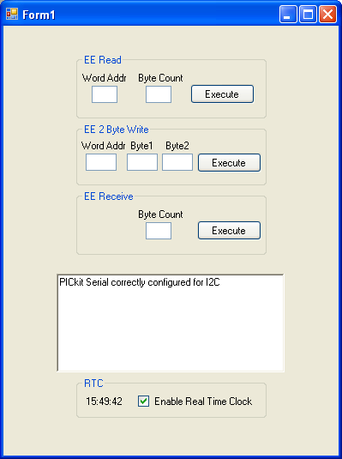

- Toggle the checkbox to make sure the timer stops and starts. You will also notice that the Busy and Target LEDs flash on/off on the PICkit Serial Analyzer with every read. Note that the RTC is running all the time, we are just enabling and disabling the timer reading it.

The label may not display 2 digit values depending on the time returned by the SMB (display shows 0:7:45 instead of 00:07:45). It is up to the reader to learn how to format the time correctly.

ADC

Now let’s look at the ADC.

- Add five new objects to the GUI and name them per below (you may have to increase the size of the GUI some):

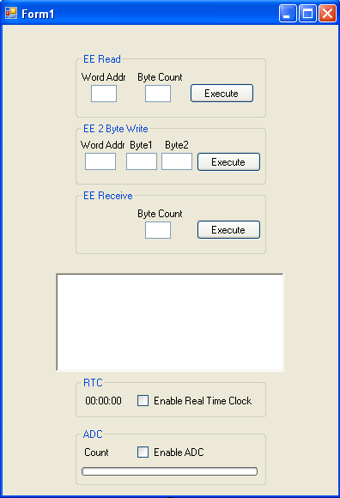

- Label_ADC_Count
- CheckBox_ADC
- ProgressBar_ADC

- Click on the progress bar and change the Maximum value to 255 in the Properties window.
- Add a timer to the form and rename it Timer_ADC. Leave the Interval property at 100ms.
- Now double click on the timer to create a subroutine called Timer_ADC_Tick
- Add the following code to the timer function:

' routine to read and display smb adc
Dim Demo_Slave_adc_Addr As Byte = &HAA
' determined by SMB firmware, &H says this is a hex number
' we are actually reading Register1 in the Demo board
Dim Word_Addr As Byte = 1
' start reading at byte 1
Dim DataArray(0) As Byte
' create array of length 1 byte to hold adc data
Dim Return_Str As String = ""
' returns string representation of command - we won't use this
Dim ADC_Count As Byte
' byte value will store adc count
Array.Clear(DataArray, 0, DataArray.Length)
' initialize array
'
If (PICkitS.I2CM.Read(Demo_Slave_adc_Addr, Word_Addr, DataArray.Length, DataArray, Return_Str)) Then
' successful, display results
ADC_Count = DataArray(0)
Label_ADC_Count.Text = "Count: " & ADC_Count.ToString()
ProgressBar_ADC.Value = ADC_Count
Else
RichTextBox_Display.Text += "Error reading ADC" & vbCrLf
PICkitS.Device.Reset_Control_Block() ' clear any errors in PKSA
' turn off timer so don't keep getting error
Timer_ADC.Enabled = False
CheckBox_ADC.Checked = False
End If

- Now double click the checkbox to create a function to toggle on and off the timer.
- Add the following code to the checkbox subroutine:

If (CheckBox_ADC.Checked) Then
Timer_ADC.Enabled = True
Else
Timer_ADC.Enabled = False
End If

- Build and run your application, Now click on the ADC checkbox to enable the timer You should get a display that looks something like this:

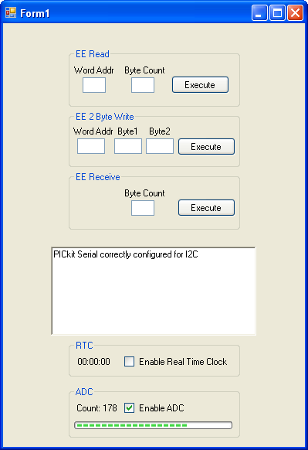

- Adjust the potentiometer and verify the count and progress bar change accordingly.
- Now disconnect the Demo board from the PICkit Serial Analyzer and verify that the error message is displayed and the ADC timer stops.

Bit Rate

Finally, let’s look at how we change the I2C bit rate.

- Add four new objects to the GUI and name them per below (you may have to increase the size of the GUI some):

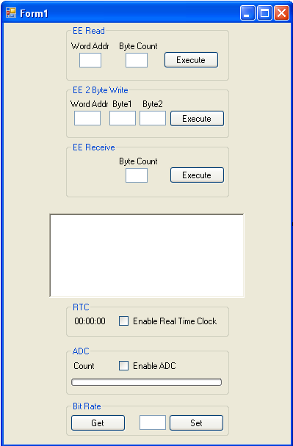

- Button_Get_Bit_Rate
- TextBox_Bit_Rate_Set
- Button_Set_Bit_Rate

- Double click the Get Button and add the following code:

Dim BitRate As Double
BitRate = PICkitS.I2CM.Get_I2C_Bit_Rate()
If (BitRate = 0) Then
RichTextBox_Display.Text += "Error retrieving I2C bit rate" & vbCrLf
PICkitS.Device.Reset_Control_Block() ' clear any errors in PKSA
Else
RichTextBox_Display.Text += "Bit rate = " & String.Format("{0:0.0}", BitRate) & " kHz" & vbCrLf
End If
- Double click the Set button and add the following code:

Dim BitRate_Set As Double
BitRate_Set = Convert.ToDouble(TextBox_Bit_Rate_Set.Text)
If (PICkitS.I2CM.Set_I2C_Bit_Rate(BitRate_Set) = True) Then
RichTextBox_Display.Text += "Bit rate set" & vbCrLf
Else
RichTextBox_Display.Text += "Error setting I2C bit rate" & vbCrLf
PICkitS.Device.Reset_Control_Block() ' clear any errors in PKSA
End If

- Build and run your application. Click the Get button to display the I2C bit rate (the initialization routine should have set it to 100kHz).

- Now change the bit rate by entering a different number into the textbox then pressing the Set button. Verify the change by pressing the Get button again. (Note – the bit rate must be in the range of 39.1 kHz <= BitRate <= 5000 kHz). The value you read back may not match exactly the value you entered due to quantization of the bit rate in the PICkit Serial firmware.

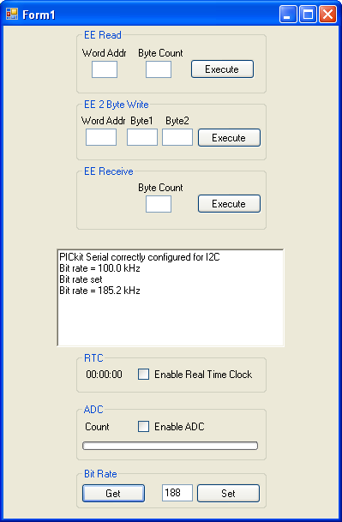

Source Voltage

Now, let’s look at how we change the I2C Source Voltage. There are two options for the source voltage. You can tell PICkit Serial Analyzer you will power your device with an external voltage source, or you can tell the PICkit Serial Analyzer to power your device within a 0.0V to 5.0V range.

- Add five new objects to the GUI and name them per below (you may have to increase the size of the GUI some):

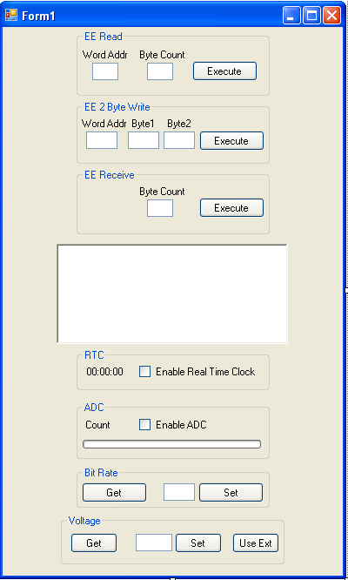

- Button_Get_Volt
- Button_Set_Volt
- Button_Use_Ext_Volt
- TextBox_Volt

- Double click the Get Button and add the following code:

Dim Volt As Double = 0
Dim PKSA_Power As Boolean
If (PICkitS.I2CM.Get_Source_Voltage(Volt, PKSA_Power)) Then
RichTextBox_Display.Text += "Source voltage set to " & String.Format("{0:0.0}V", Volt) & vbCrLf & "PKSA powering device is set to " & PKSA_Power.ToString() & vbCrLf
Else
RichTextBox_Display.Text += "Error retrieving source voltage" & vbCrLf
PICkitS.Device.Reset_Control_Block() ' clear any errors in PKSA
End If

- Double click the Set button and add the following code:

Dim Volt As Double
Volt = Convert.ToDouble(TextBox_Volt.Text)
If (PICkitS.I2CM.Set_Source_Voltage(Volt)) Then
RichTextBox_Display.Text += "Voltage Set to " & Volt.ToString() & vbCrLf
Else
RichTextBox_Display.Text += "Error setting Voltage" & vbCrLf
PICkitS.Device.Reset_Control_Block() ' clear any errors in PKSA
End If

- Double click the Use Ext button and add the following code:

If (PICkitS.I2CM.Tell_PKSA_To_Use_External_Voltage_Source()) Then
RichTextBox_Display.Text += "PKSA set to use external voltage source" & vbCrLf
Else
RichTextBox_Display.Text += "Error telling PKSA to use external voltage source" & vbCrLf
PICkitS.Device.Reset_Control_Block() ' clear any errors in PKSA
End If

- Build and run your application. Click the Get button to display the I2C voltage (the initialization routine should have set it to ~5 volts and PKSA should be powering the device).

- Now change the voltage by entering a different number into the textbox then pressing the Set button. Verify the change by pressing the Get button again. (Note – the voltage must be in the range of 0.0 <= voltage <= 5.0). The value you read back may not match exactly the value you entered due to rounding in the PICkit Serial firmware.

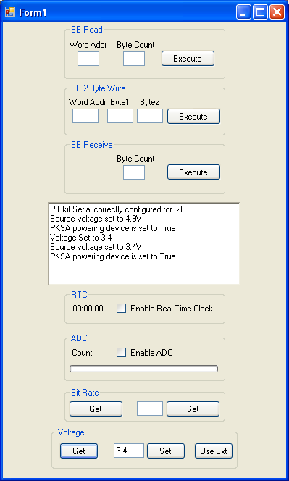

- Now press the Use Ext button and then the Get button again. The voltage should be zero and PKSA powering your device should be set to false.

AUX Status

Finally, let’s look at I2C Auxilary lines. We can cotrol the state and direction of Aux lines 1 and 2.

- Add seven new objects to the GUI and name them per below (you may have to increase the size of the GUI some):

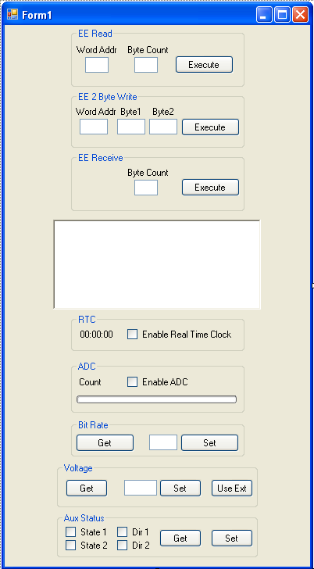

- Button_Get_Aux_Status
- Button_Set_Aux_Status
- CheckBox_State_1
- CheckBox_State_2
- CheckBox_Dir_1
- CheckBox_Dir_2

- Double click the Get Button and add the following code:

Dim Aux1_State, Aux1_Dir, Aux2_State, Aux2_Dir As Boolean
If (PICkitS.I2CM.Get_Aux_Status(Aux1_State, Aux2_State, Aux1_Dir, Aux2_Dir)) Then
CheckBox_State_1.Checked = Aux1_State
CheckBox_State_2.Checked = Aux2_State
CheckBox_Dir_1.Checked = Aux1_Dir
CheckBox_Dir_2.Checked = Aux2_Dir
RichTextBox_Display.Text += "Retrieved Aux status" & vbCrLf
Else
RichTextBox_Display.Text += "Error retrieving Aux status" & vbCrLf
PICkitS.Device.Reset_Control_Block() ' clear any errors in PKSA
End If

- Double click the Set button and add the following code:

Dim Result As Boolean = False
If (PICkitS.I2CM.Set_Aux1_Direction(CheckBox_Dir_1.Checked)) Then
If (PICkitS.I2CM.Set_Aux2_Direction(CheckBox_Dir_2.Checked)) Then
If (PICkitS.I2CM.Set_Aux1_State(CheckBox_State_1.Checked)) Then
If (PICkitS.I2CM.Set_Aux2_State(CheckBox_State_2.Checked)) Then
Result = True
End If
End If
End If
End If
If (Result = True) Then
RichTextBox_Display.Text += "Aux status set" & vbCrLf
Else
RichTextBox_Display.Text += "Error setting Aux status" & vbCrLf
PICkitS.Device.Reset_Control_Block() ' clear any errors in PKSA
End If

- Now build and execute your application. Try changing the state and direction of the aux lines using the set button and then confirming the change by using the get button. (Note – the state of the aux lines may float high if the direction is set to input (true) and PKSA is set to power the device – even if the state was not set.

Other Functions

It is worth mentioning a few other functions not used in the accompanying example project. See PICkitS Function Prototypes.doc for more details.

The functions below are part of class PICkitS.I2CM

public static bool Configure_PICkitSerial_For_I2CMaster(bool p_aux1_def,
bool p_aux2_def,
bool p_aux1_dir,
bool p_aux2_dir,
bool p_enable_pu,
double p_voltage)

Overrides Configure_PICkitSerial_For_I2CMaster () to include options for aux status, pull-ups, and voltage.

public static bool Set_Pullup_State(bool p_enable)

Sets state of pull-ups – enabled or disabled.

public static void Flash_LED1_For_2_Seconds()

Found in PICkitS.Device – can be called anytime to flash LED1 for approximately 2 seconds. Used to verify communication with PICkit Serial Analyzer. Flashing will stop on its own – there is no function call to stop flashing.

public static void Set_Script_Timeout(int p_time)

Found in PICkitS.Device – When sending any script to the PICkit Serial Analyzer, the dll will wait for the script to complete and then verify there were no status errors. The script timeout is the maximum time the dll will wait for the script to finish. The default value is 3000 (three seconds).

public static bool There_Is_A_Status_Error(ref uint p_error)

This function is in PICkitS.Status and can be used to get detailed error information. You would call this function after an error, but before the

PICkitS.Device.Reset_Control_Block() function call.

Note – whenever you call PICkitS.Device.Reset_Control_Block(), some of your parameters may get reset to default values. A good practice is to create a setup function in your application that sets all of the parameters you are interested in – then call that function from the Form1_Load routine and everytime you get an error from the PICkit Serial Analyzer.

